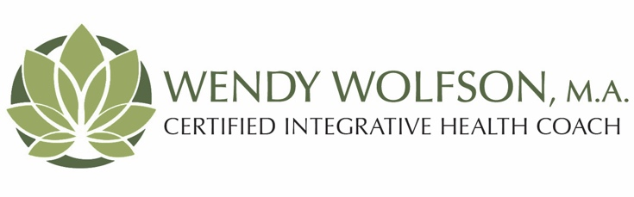
If you are considering Health & Well-Being Coaching, or you have already made a commitment, here is some information that you may find useful before you attend your first session.

What is Health & Well-Being Coaching?
Are there health behavior changes that you have wanted to make but either have not known how or haven’t been successful in the past? Has a new health concern arisen that you want to pay particular attention to? Health coaching effectively motivates and supports health behavior change through a structured partnership between the client and coach. A coach is like a “personal trainer” except the focus will be on your whole self. The coach helps the client develop and realize their optimal health vision through inquiry, personal discovery, and accountability.

Why is it effective in helping people realize their optimal health?
- Coaches work with the whole person. They listen to your concerns and ask powerful questions to help motivate you to make the changes you desire.
- Coaches spend time exploring what is most important to you in your health and allow you to choose your course of action.
- Coaches guide you through a process to maximize the possibility of your success.
- You and your coach work in partnership to identify obstacles to change and create strategies.
for moving forward toward your goals.
- Coaches support you in tracking your weekly progress and hold you accountable for your commitments.
- Coaches provide additional resources for making healthy behavior changes.

What are appropriate topics for health coaching?
The coaching relationship is unique. The coach and the client form a partnership to better equip you to realize your optimal health vision based on your own goals and values. Any concern that gets in the way of taking care of your optimal health is the perfect subject with which to begin coaching. Therefore, any topic you want to bring up that you think will contribute to your optimal health is an appropriate topic for Health & Well-Being Coaching.

